NYSSA (New YOrk society for security analyst), New York City, NY
Apr 06 – Feb 02, Business Analyst
Environment: UML, Rationale Rose, MS Project, Requisite Pro, Oracle, CRM, IVR, SOLOMON, PGP, SSH, sFTP.

NYSSA is a leading forum for the investment community. It offers CFA Programs and conducts various programs for investment leaders. NYSSA is also funded by top investment banks across Manhattan, NY. The project involved upgrading the present accounting software i.e. SOLOMON, and also to incorporate new applications in the software. The new software also incorporated the Treasury management Products like Account Reconciliation, Accounts Payable, Account Receivables, Lockbox Report and Positive pay. The project scope also covered file transfer from the old version of SOLOMON.

Responsibilities:

- Worked jointly with Business Analysts in gathering requirements and implementing new functionalities and reports.
- Involved in the analysis of the functional and technical specifications, and the data mapping document.
- Created Project Charter Documents/Business Requirement Documents and prepared Use-Case Specifications, System Requirements Specification and UI Functional specification documents.
- Conducted business meetings to understand the AS IS and TO BE processes; developed a documented with comprehensive GAP analysis details.
- Worked on PGP software deployed within the company’s file transfer platform.
- Accountable for data transmissions to various Departments reporting through SOLOMON utilizing EDI formats such as X12.
- Conducted JAD sessions with the Accounting team in order to understand the functionality of the Main and Sub Accounts.
- Documented and mapped the changing requisites in Bank Reconciliation, Accounts Receivable and Accounts Payable.
- Developed excel applications using complex functionalities like VLOOKUP and PIVOT TABLES to streamline various processes for analysis and reconciliation.
- Worked as a liaison between the Accounting Department and the different teams involved in the application development for better understanding of the business and IT processes.
- Manual testing for checking the data flow of the application using SQL.
- Developed QA Project Plan, Test Strategy, and Test Plan from the system requirements specifications. Reviews test methodologies and execution results.
- Developed Functionality and Permission Group verification Test Cases for Back Office Module by referring Use Cases.
Developed final test cases, of data transfer schedules. This included transferring the data secretively to Revenue, Payables, receivables, budgeting and other sub accounts.

What is the project about?

The project is about up gradation of the software i.e. SOLOMON. This is a software which is used by many midsized companies for accounting purposes. The company had widened its operations and clients, and required an up gradation in the sub accounts, Main Accounts and other reporting accounts to support the new business.

Following are some of the uses of SOLOMON in accounting:
- Create journal transactions to update General Ledger accounts.
- Execute the posting process and view the results of the transactions in the General Ledger accounts.
- Identify the appropriate use for the types of batches available for journal transactions.
- Define Ledgers to track budgets, statistical accounts, and foreign currency accounting records for use in financial reporting.
- Use appropriate General Ledger processes to perform accounting cycle functions such as creating journal transactions, posting to general ledger accounts, closing the accounting period, budgeting, and allocating account balances.
- Identify transactions created in related modules and their effect on the General Ledger account balances.
- Troubleshoot and correct operator input errors including incorrect period to post, entries to incorrect accounts, and correcting batches from sub modules that impact the General Ledger.
- Define set up options for the module that allow you to customize your system to better fit your organization’s unique needs.
- Worked on setting up the Accounts reconciliation Program of the company
- Worked on the Lockbox reports and positive pay of company’s reporting accounting software.

Business flow Diagram:

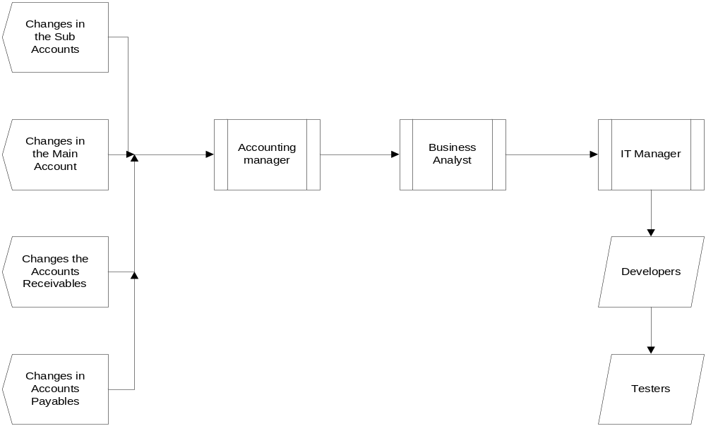
Treasury management Products

SOLOMON UPGRADED FEATURES:

Solomon was the accounting software which NYSSA was using and there were requirements which came up for up gradation of the following parameters in the reporting software:

- ARP
- Accounts Payable
- Accounts Receivables
- General Ledgers
- Lock box Reports
- Positive pay
- Main Accounts
- Sub Accounts

ARP Account Reconciliation:

To provide a method for reconciling the accounts to the monthly financial reports produced by the Financial Records System. Reconciliation is the process of comparing departmental account records to the reports generated from FRS to verify the accuracy of each. The responsible person for each account is required to verify or perform this procedure every month. Account reconciliation is essential to ensure accurate reports, because it identifies errors and inconsistencies requiring correction.
The company received payments for its line of operation either by check, cash. With the latest improvement in paying online the company also started accepting the credit cards. Hence the company’s Accounting software SOLOMON had to be upgraded to incorporate the new payment method of the customers. With this the Account reconciliation of SOLOMON also had to be upgraded.

How the SOLOMON conducted account reconciliation?
The General ledgers, accounts receivables, Account Payables, receipts of the payments, very sign reports, Amex reports are maintained in excel sheets. These excel sheets are imported to the software. Then the software matches the accounts with the bank statements which they get in the form of hard copy or CD Rom, then the values are matched

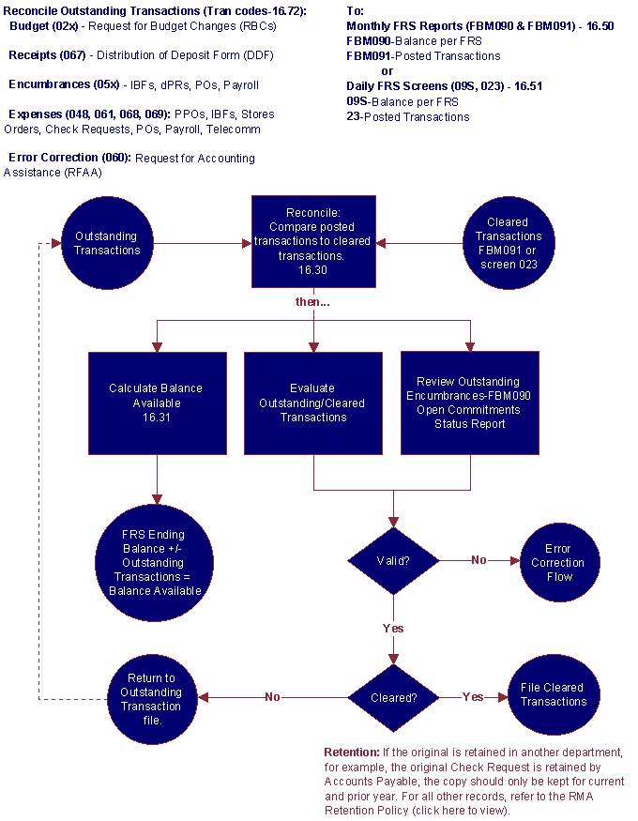
Full Reconciliation
You furnish SOLOMON with issued check information on an electronic file. SOLOMON reconciles your bank balance to your ledger balance. Additional reports include stop payments, voids, and items posting against your account for which issuance information has not been provided.
Partial Reconciliation
With this service, SOLOMON provides you with a listing of all checks paid during the statement period. The paid checks listing indicates check number, paid date and dollar amount.
Deposit Reconciliation
Tracking deposits from multiple locations to a single DDA is simple with SOLOMON Deposit Reconciliation service. Available on a daily, weekly or monthly basis, deposit reconciliation groups deposits by location number as encoded on the deposit ticket.

ACCOUNTS PAYABLE

Accounts payable is a file or account that contains money that a person or company owes to suppliers, but has not paid yet (a form of debt). When you receive an invoice you add it to the file, and then you remove it when you pay. Thus, the A/P is a form of credit that suppliers offer to their purchasers by allowing them to pay for a product or service after it has already been received. The profession is unregulated, though there are international standard setting bodies, an example of which is the International Accounts Payable Professionals (IAPP), an association of more than 5,000 members in the United States, Canada, the United Kingdom and other countries. As part of its Professional Standards Framework, the IAPP has established a new definition of accounts payable.

The SOLOMON imports the excel sheet which tabulates the payment which have to be debited from the revenue account. This is useful when matched for Partial Reconciliation.

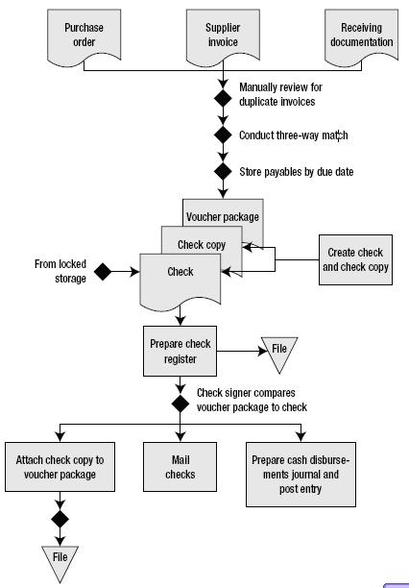

ACCOUNTS RECIVABLES:

Accounts receivable (A/R) is one of a series of accounting transactions dealing with the billing of customers who owe money to a person, company or organization for goods and services that have been provided to the customer. In most business entities this is typically done by generating an invoice and mailing or electronically delivering it to the customer, who in turn must pay it within an established timeframe called credit or payment terms.

The SOLOMON imports the excel sheet which tabulates the payment which have to be credited to the revenue account. This is useful when matched for Partial Reconciliation.

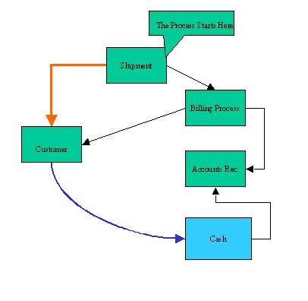
LOCK BOX REPORT

The objective of a lockbox operation is to have the customer remit a payment check to a local post office box to minimize mail transit time. The checks are processed by the bank on a daily basis and the funds collected are usable by the receiving business much quicker than with the traditional process. NYSSA uses FISC which provides outsourced business solution.
These are generally done for big businesses. In order to minimize float time for your business, FISC, as your lockbox vendor, will make multiple mail pick-ups each day; process the payments immediately; deposit funds; and provide payment information to update your receivables. Depending upon the type of payments your business receives, FISC can provide one of the following types of lockbox services appropriate for your business.
FISC acted as an interface between HSBC and NYSSA. We could have worked directly with HSBC but since there was SOLOMON software which needed to integrate with HSBC, we had to use FISC in between.
FISC Solutions include:
- Retail, Wholesale and Whole tail Lockbox Processing: http://www.fiscsolutions.com/lockbox_retail.php
- Electronic Check Clearing – FISCheckAccelerator: http://www.fiscsolutions.com/lockbox_fischeckaccelerator.php
- Accounts Receivable Conversion (ARC): http://www.fiscsolutions.com/lockbox_arc.php
- Invoice Delivery and Payment Collections – Round Trip Ticket: http://www.fiscsolutions.com/lockbox_roundtripticket.php
- Electronic Lockbox – FISC pay: http://www.fiscsolutions.com/lockbox_fiscpay.php

SOLOMON upgraded version will maintain a track of all the checks paid by the customers of NYSSA which defaulted. This is a new sub account which will be incorporated in SOLOMON. Some of these payments will bounce due to NSF or fraud checks. Any fees that the bank charges NYSSA will be charged back to NYSSA’s customers (and hence marked as accounts receivable from the customer).

POSITIVE PAY:

Positive Pay is an automated fraud detection tool offered by the Cash Management Department of most banks. In its simplest form, it is a service that matches the account number, check number and dollar amount of each check presented for payment against a list of checks previously authorized and issued by the company. All three components of the check must match exactly or it will not pay.
Positive Pay requires the company to send (transmit) a file of issued checks to the bank each day checks are written. When those issued checks are presented for payment at the bank, they are compared electronically against the list of transmitted checks. The check-issue file sent to the bank contains the check number, account number, issue date, and dollar amount. Sometimes the payee name is included, but is not part of the matching service. When a check is presented that does not have a "match" in the file, it becomes an "exception item". The bank sends a fax or an image of the exception item to the client. The client reviews the image and instructs the bank to pay or return the check.There is generally a fee charged by the bank for Positive Pay, although some banks now offer the service for free. The fee might well be considered an "insurance premium" to help avoid check fraud losses and liability.

DATA TRANSFER

sFTP over SSH Network
SOLOMON (OLD VERSION)
SOLOMON (NEW VERSION)
WHOLESALE TREASURY COMPONENTS OF NYSSA (MAINTAINED IN EXCEL FORMAT): (Previous & New Req.)
ARP, Accounts Receivables, Accounts Payable, Lock Box, Positive Pay, Main and Sub Accounts, General Ledgers
NYSSA reporting Bank, HSBC
Customers
Third party processor
REMOTE SERVER
Contains historical
Transaction of NYSSA
With banks, customers, events, and other budgetary transactions.
sFTP over SSH Network
Connect: Direct
sFTP over SSH Network

